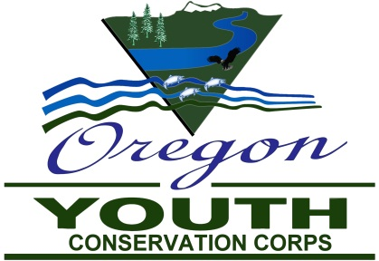
2014 OYCC Adopt-A-River
Reporting

Grant Number: Click here to enter text.

Program Name: Click here to enter text.

Project Location: Click here to enter text.

Number of Participants: Click here to enter text. Total Hours Worked: Click here to enter text.

Please provide a brief description of what was accomplished: Click here to enter text.

If you removed trash, please estimate the pounds of trash removed (please note, one bag weighs approximately 30 lbs.): Click here to enter text.

If you removed invasive species, please list the species removed and the approximate square footage cleared: Click here to enter text.

What was the most interesting item(s) found? Click here to enter text.

